**Assignment MySQL**

**Table 1: SalesPeople**

**Snum is Primary key**

**Sname is Unique constraint**

**Snum Sname City Comm**

**1001 Peel. London .12**

**1002 Serres Sanjose .13**

**1004 Motika London .11**

**1007 Rifkin Barcelona .15**

**1003 Axelrod Newyork .10**

**Syntax:**

**CREATE TABLE salespeople (**

**Snum INT PRIMARY KEY,**

**Sname VARCHAR(30) UNIQUE ,**

**City VARCHAR(30),**

**Comm INT**

**);**

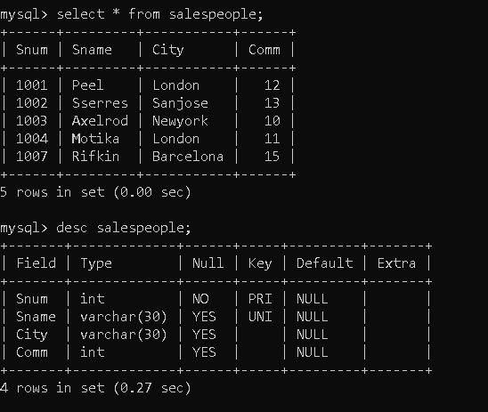

**Table 2: Customers**

**Cnum is Primary Key**

**City has not null constraint .**

**Snum is foreign key constraint refers Snum column of SalesPeople table.**

**Cnum Cname City Snum**

**2001 Hoffman London 1001**

**2002 Giovanni Rome 1003**

**2003 Liu Sanjose 1002**

**2004 Grass Berlin 1002**

**2006 Clemens London 1001**

**2008 Cisneros Sanjose 1007**

**2007 Pereira Rome 1004**

**Syntax:**

**Create Table Customers(Cnum INT PRIMAY KEY,**

**Cname VARCHAR(30),**

**City VARCHAR(30) NOT NULL,**

**Snum INT,**

**FOREIGN KEY (Snum) REFERENCES Salespeople(Snum)**

**);**

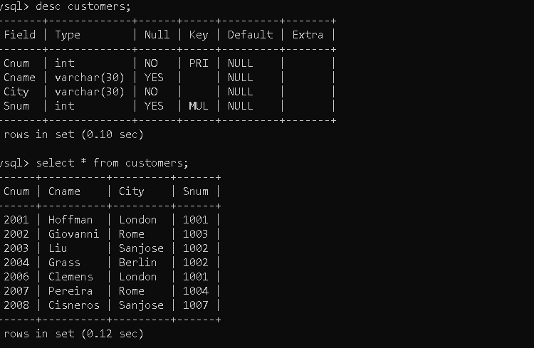

**Table 3: Orders**

**Onum is Primary key**

**Cnum is foreign key refers to Cnum column of Customers table. Snum is foreign key refers Snum column of SalesPeople table.**

**Onum Amt Odate Cnum Snum**

**3001 18.69 3-10-1990 2008 1007**

**3003 767.19 3-10-1990 2001 1001**

**3002 1900.10 3-10-1990 2007 1004**

**3005 5160.45 3-10-1990 2003 1002**

**3006 1098.16 3-10-1990 2008 1007**

**3009 1713.23 4-10-1990 2002 1003**

**3007 75.75 4-10-1990 2004 1002**

**3008 4273.00 5-10-1990 2006 1001**

**3010 1309.95 6-10-1990 2004 1002**

**3011 9891.88 6-10-1990 2006 1001**

**Syntax:**

**CREATE TABLE orders (**

**Onum INT PRIMARY KEY,**

**Amt decimal(6,2),**

**Odate VARCHAR(10) NOT NULL,**

**Cnum INT NOT NULL,**

**Snum INT NOT NULL,**

**FOREIGN KEY (Cnum) REFERENCES Customers(Cnum),**

**FOREIGN KEY (Snum) REFERENCES Salespeople(Snum)**

**);**

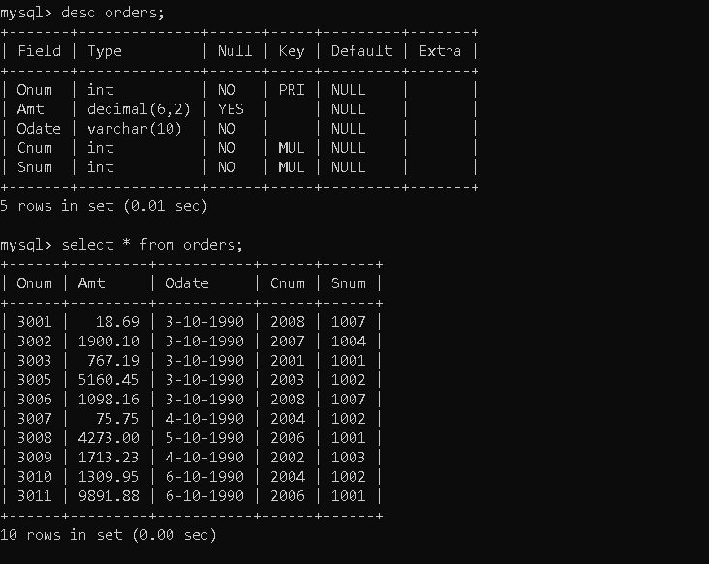

**On the basis of above tables specific tasks has been performed according to the questions:**

**Count the number of Salesperson whose name begin with ‘a’/’A’.**

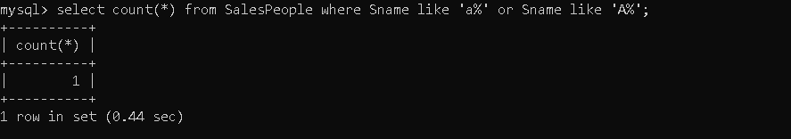

**Display all the Salesperson whose all orders worth is more than Rs. 2000.**

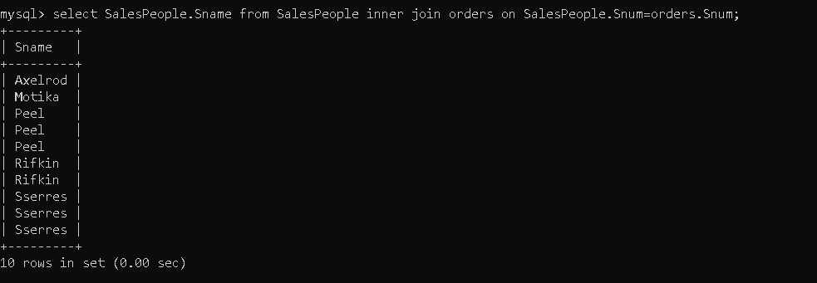

**Count the number of Salesperson belonging to Newyork.**

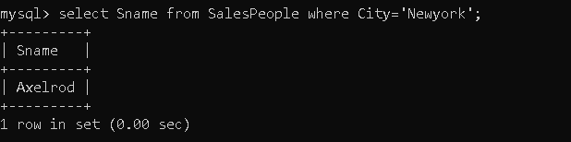

**Display the number of Salespeople belonging to London and belonging to Paris.**

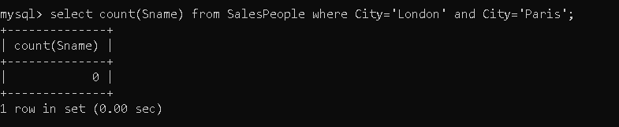

**Display the number of orders taken by each Salesperson and their date of orders.**

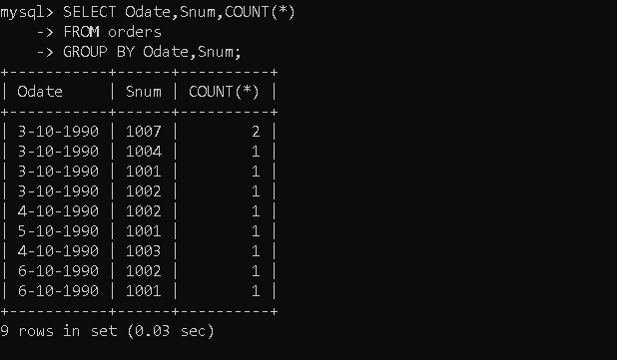

**BY NOREEEN**